Strategic Product Placement Analysis: Unveiling Sales Impact with Tableau Visualization
1. Project Title
Strategic Product Placement Analysis: Unveiling Sales Impact with Tableau Visualization

2. Introduction
In the retail industry, product placement plays a major role in influencing customer purchasing decisions. Proper placement of products in high visibility areas such as end-caps, aisles, and front-of-store locations can significantly increase sales volume. Retail companies also need to consider factors like promotions, seasonal demand, consumer demographics, competitor pricing, and foot traffic to maximize revenue.
This project focuses on analyzing supermarket product positioning data and generating meaningful insights using Tableau dashboards and stories. The goal is to provide a data-driven approach to help retailers improve product placement strategies and boost sales performance.

3. Problem Statement
Retail stores face high competition and need to increase sales and customer engagement. However, it is difficult to decide which product categories should be placed in which store positions to maximize sales. Manual analysis of sales data is time-consuming and inefficient.
Therefore, a visualization-based solution is required to analyze product placement data and identify the best placement strategies based on sales volume, pricing, foot traffic, demographics, and promotions.

4. Objectives
The main objectives of this project are:
- To analyze average sales volume across product categories.
- To study how product position affects sales volume.
- To evaluate the impact of foot traffic on sales.
- To analyze consumer demographics contribution to sales.
- To compare competitor price with actual product price.
- To study the effect of promotions on sales and pricing.
- To analyze the impact of seasonal demand on sales.
- To create a Tableau Dashboard and Story for interactive insights.
- To publish the dashboard using Tableau Public and embed it into a Flask web application.

5. Dataset Description
The dataset contains historical product positioning and sales details collected from supermarket stores.
https://www.kaggle.com/datasets/amitvkulkarni/impact-of-product-positioning-on-sales
Important Attributes
- Product Category (Clothing, Electronics, Food)
- Product Position (Aisle, End-cap, Front of Store)
- Sales Volume
- Price
- Competitor’s Price
- Consumer Demographics (College Students, Families, Seniors, Young Adults)
- Foot Traffic (Low, Medium, High)
- Seasonal (Yes/No)
- Promotion (Yes/No)

6. Tools and Technologies Used
Tableau Desktop
- Used to create data visualizations
- Created Dashboard and Story
Tableau Public
- Used to publish and share dashboard online
Flask Framework
- Used to create a web application to embed Tableau dashboard and story
Python
- Used for Flask server-side integration

7. System Requirements
Hardware Requirements
- Minimum 4GB RAM (Recommended 8GB+)
- Intel i3 processor or higher
- 10GB free storage
Software Requirements
- Windows OS
- Tableau Desktop
- Tableau Public Account
- Python 3.x
- Flask Framework
- Browser (Chrome/Edge)

8. Methodology / Project Workflow
The project was completed using the following steps:
- Dataset collection and cleaning
- Importing dataset into Tableau
- Creating calculated fields (if needed)
- Building visualizations (charts, graphs, tables)
- Designing dashboard layout
- Adding interactive filters
- Creating story points for final insights
- Publishing dashboard and story on Tableau Public
- Embedding dashboard and story into Flask website
- Testing and documentation

9. Visualizations Created
The following sheets were created in Tableau:
Sheet 1: Avg Sales Volume vs Product Category
- Bar chart showing average sales volume across product categories.
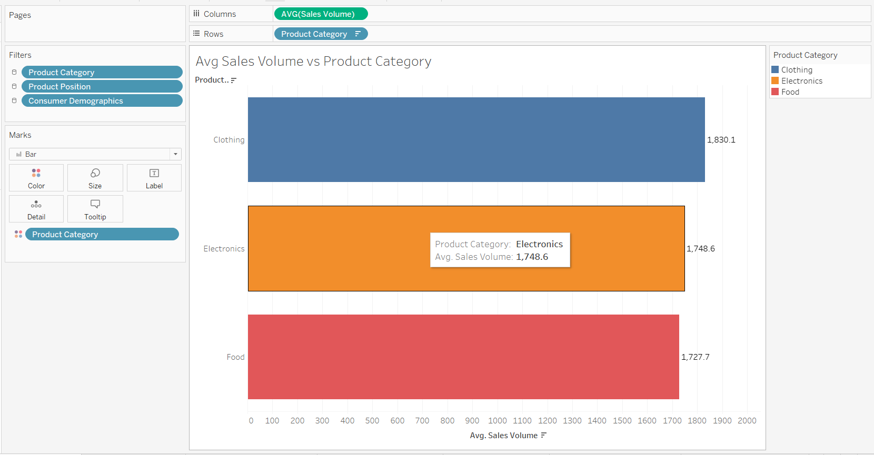
Sheet 2: Competitor Price vs Price
- Comparison between average product price and competitor’s price.
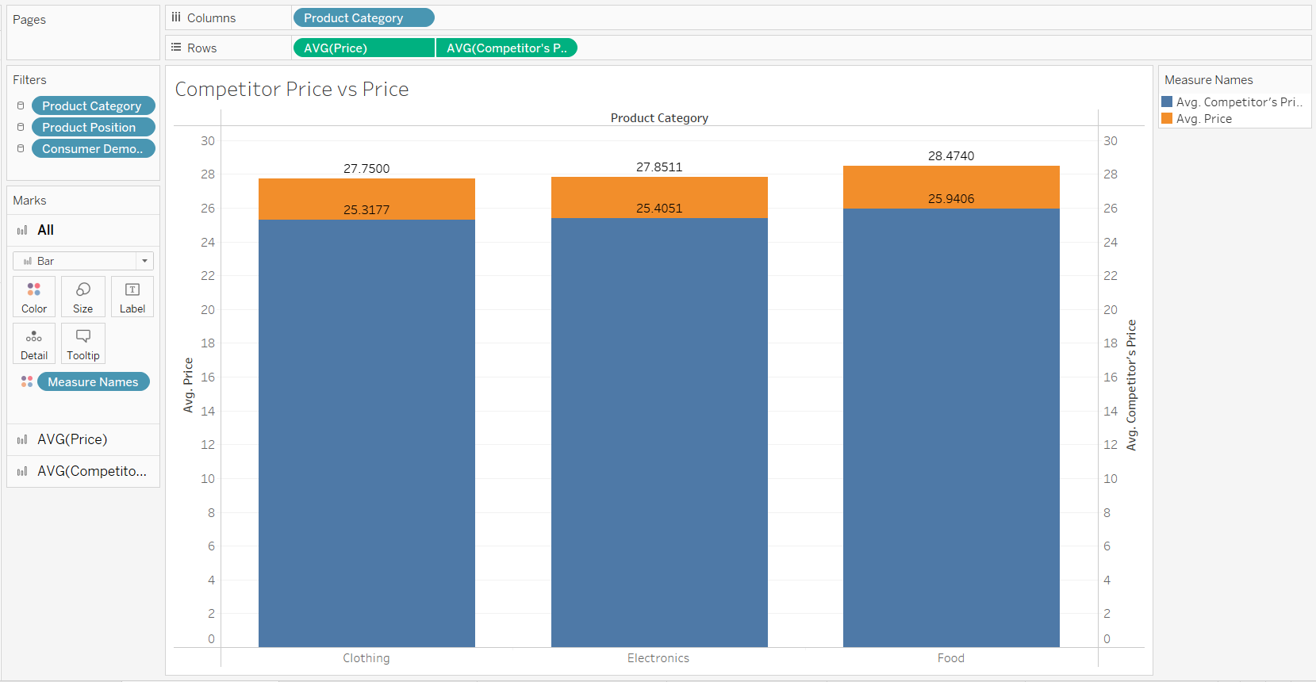
Sheet 3: Avg Sales by Category by Position
- Shows average sales volume for each product category based on placement position.
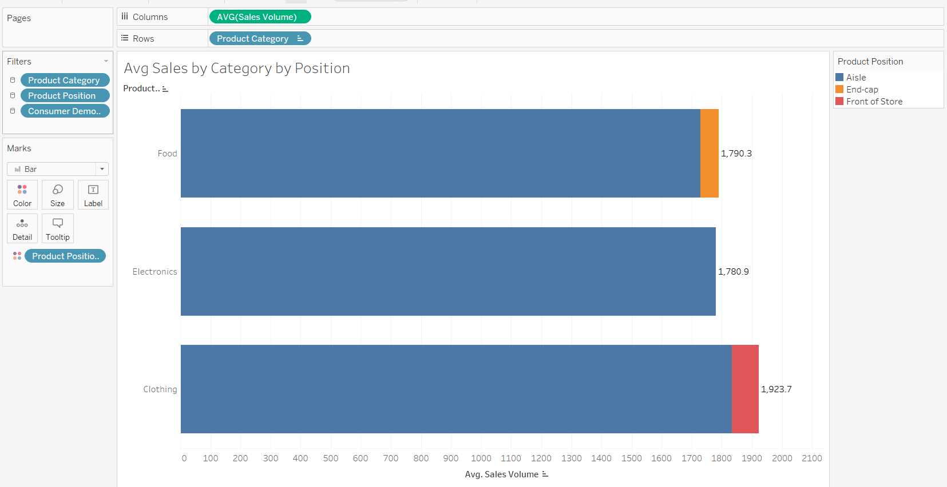
Sheet 4: Demographics vs Sales Volume
- Donut chart representing sales volume contribution from different consumer demographic groups.
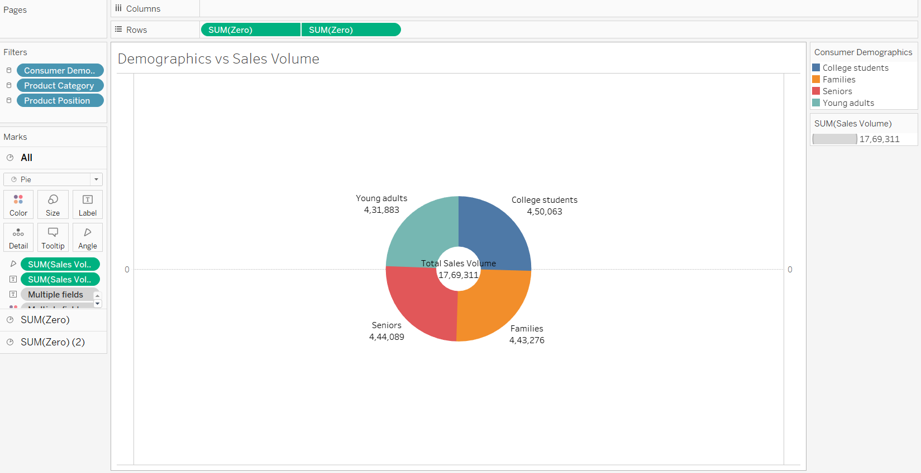
Sheet 5: Product Category vs Price
- Pie chart showing average product price distribution across categories.
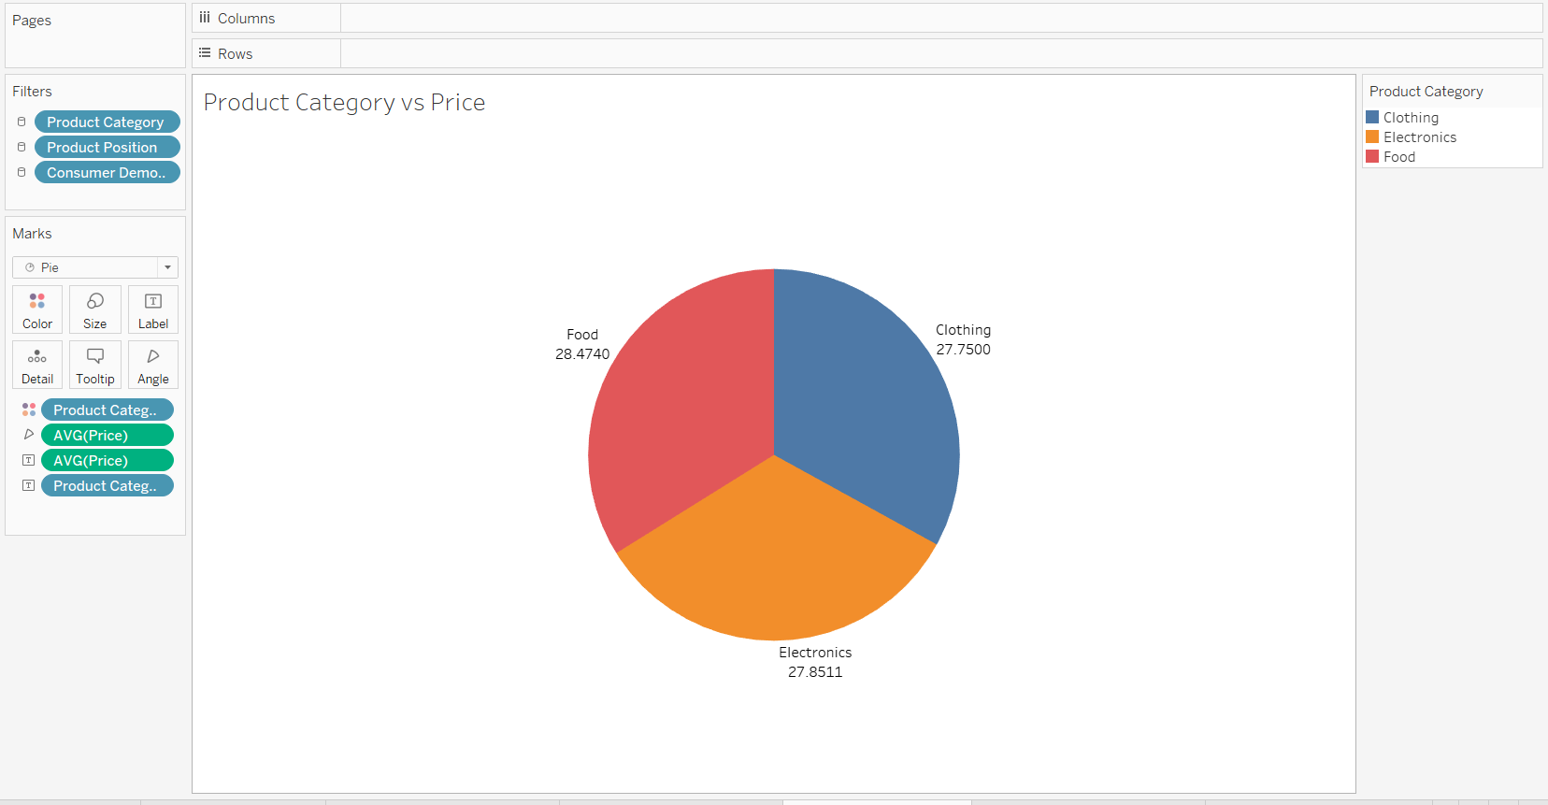
Sheet 6: Avg Sales by Category by Season
- Stacked bar chart showing sales comparison for seasonal vs non-seasonal products.
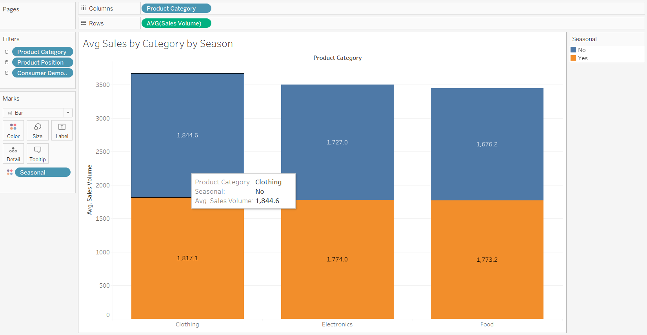
Sheet 7: Foot Traffic by Avg Sales Volume
- Bubble chart showing how foot traffic impacts sales volume for different positions.
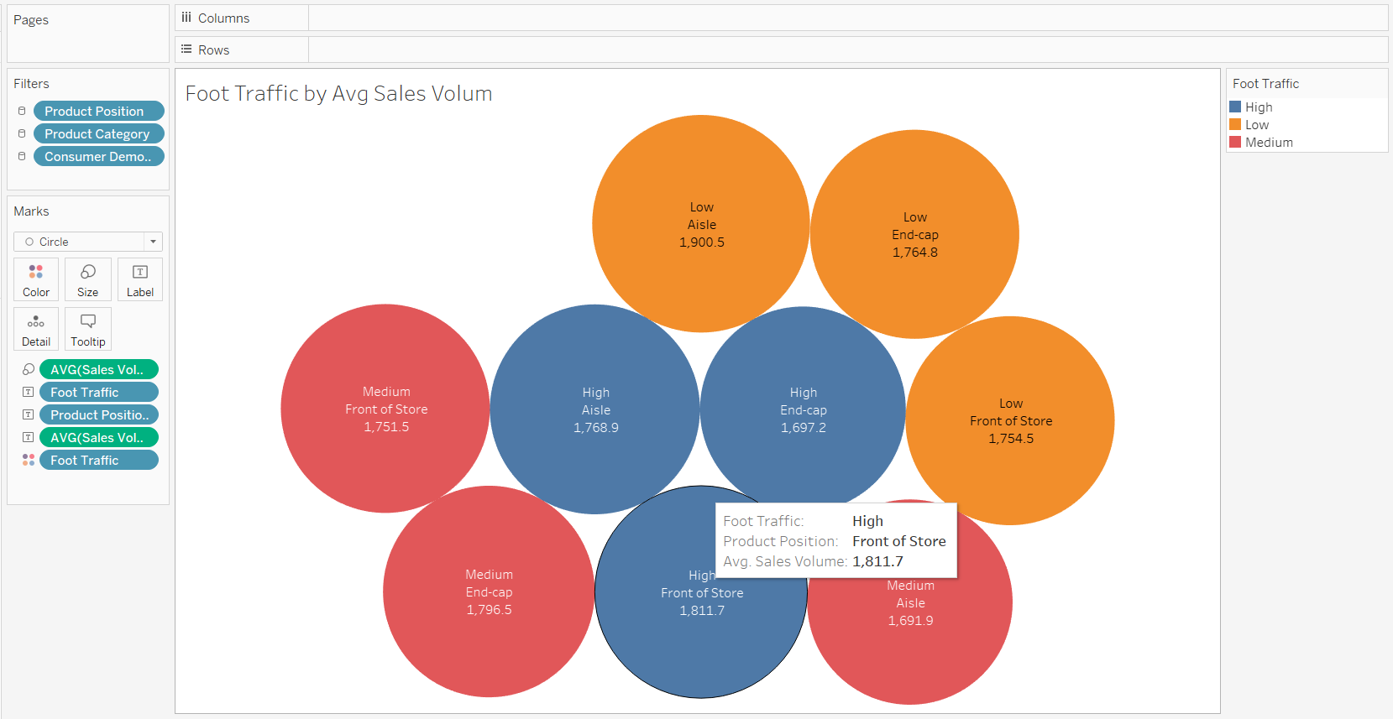
Sheet 8: Promotion Impact Table
- Text table showing average price and sales volume for promotion vs no promotion.
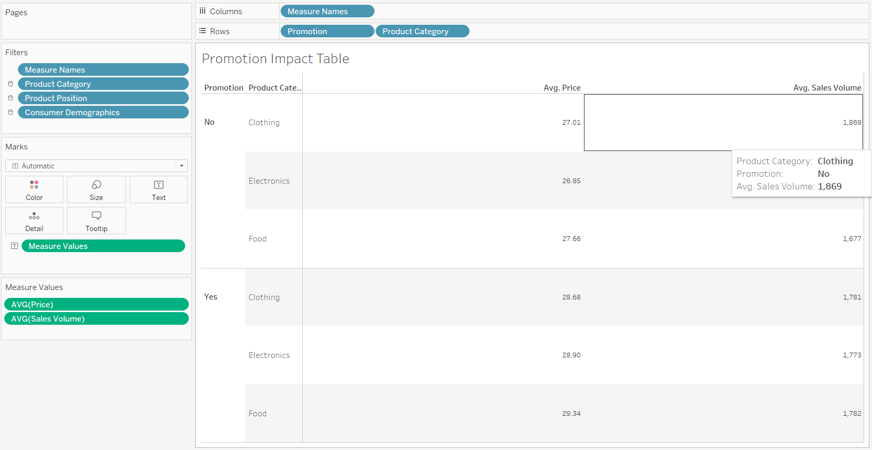
10. Dashboard Description
A dashboard titled “Product Placement Analysis Dashboard” was created by combining all the sheets. The dashboard provides a complete overview of:
- category performance,
- placement impact,
- seasonal sales,
- demographic contribution,
- competitor pricing, and
- promotional impact.
Interactive filters were added for:
- Product Category
- Product Position
- Consumer Demographics
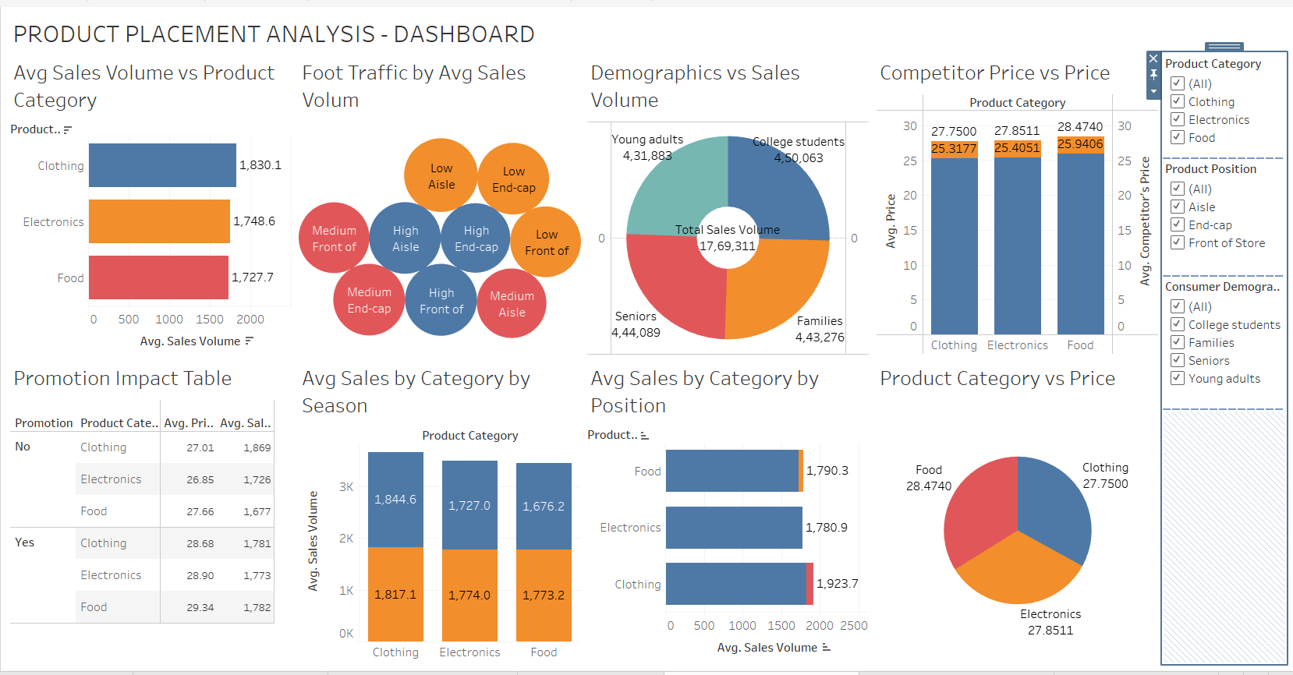
11. Story Description
A Tableau Story titled “Product Placement Analysis Story” was created with multiple story points to explain insights step-by-step. The story helps understand:
- which category performs best,
- which position is most effective,
- which placement strategy gives maximum sales.
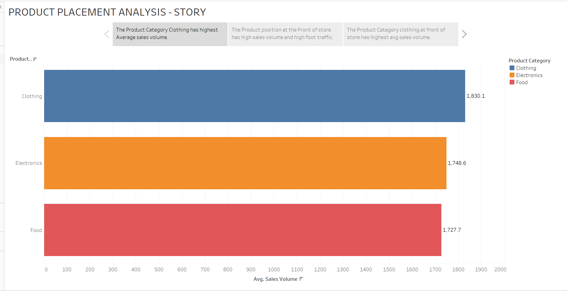
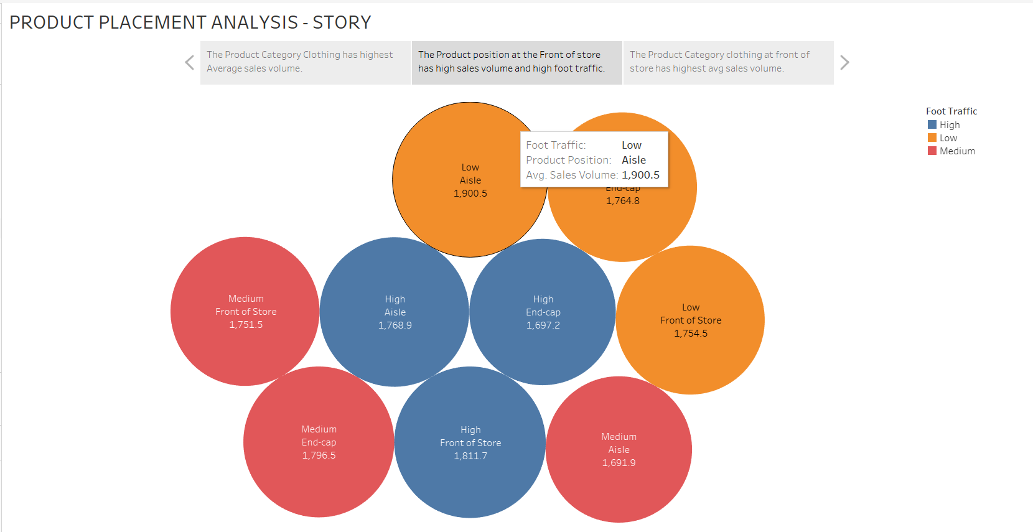
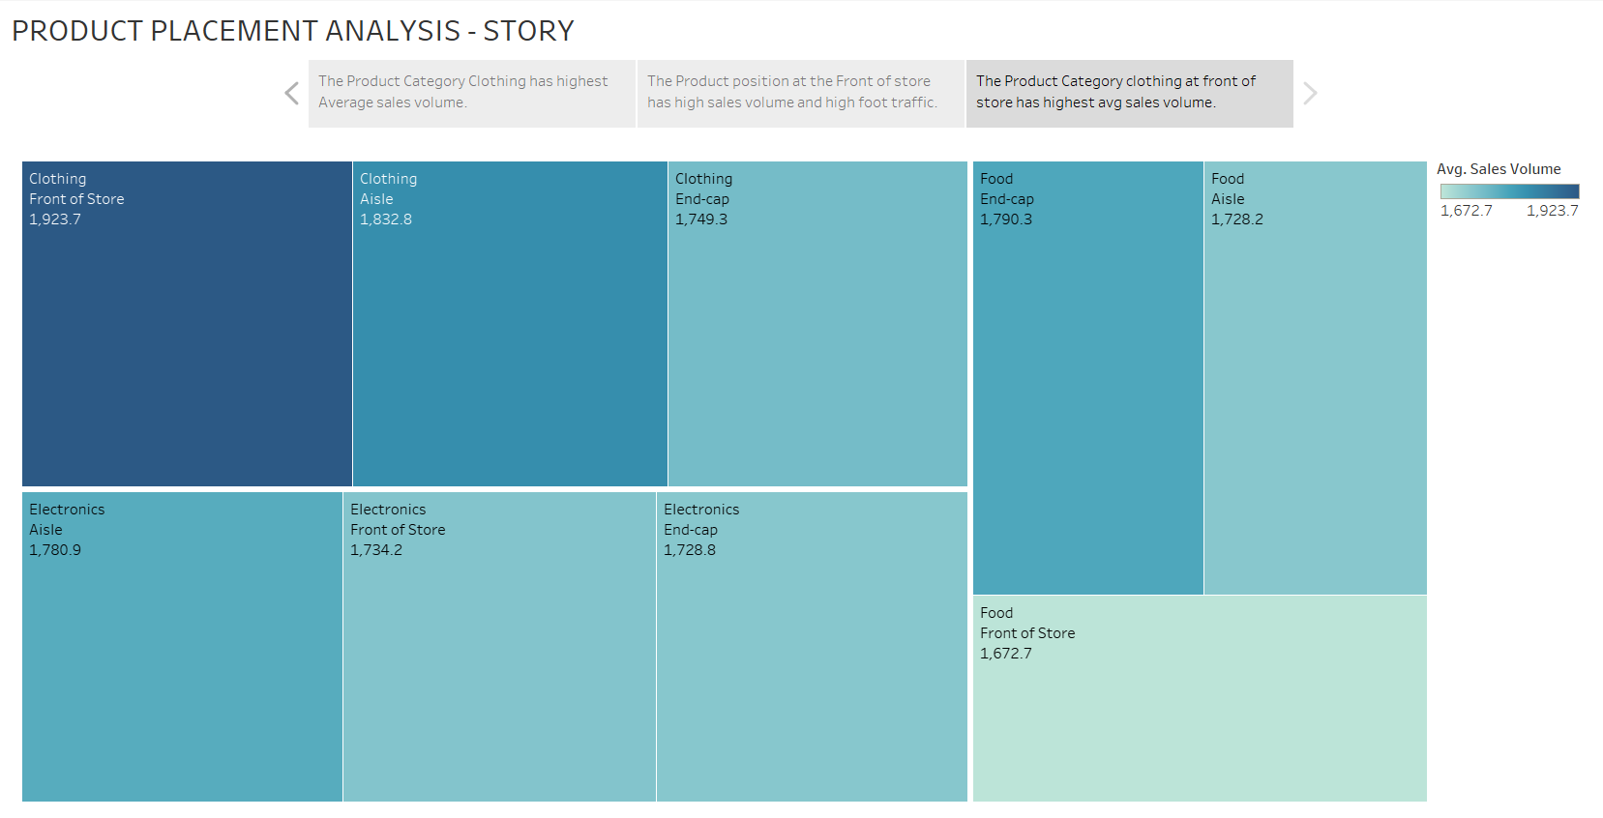

12. Results and Insights
After analysis, the following insights were obtained:
1. Best Product Category
- Clothing category has the highest average sales volume compared to Electronics and Food.
2. Best Product Position
- Products placed at Front of Store show higher sales volume because customers see them first.
3. Consumer Demographics
- College students and families contribute significantly to total sales volume.
4. Foot Traffic Impact
- High foot traffic zones generate better sales volume compared to low traffic areas.
5. Promotion Impact
- Promotion increases customer attention and improves sales volume slightly compared to no promotion.
6. Competitor Price Comparison
- Competitor pricing affects product pricing strategy, and price differences impact sales.
7. Seasonal Sales
- Seasonal products show increased demand compared to non-seasonal products.

13. Deployment
The Tableau dashboard and story were published on Tableau Public.
They were embedded into a Flask web application to display the analysis through a browser.
The Flask app provides navigation pages:
- Dashboard Page
- Story Page
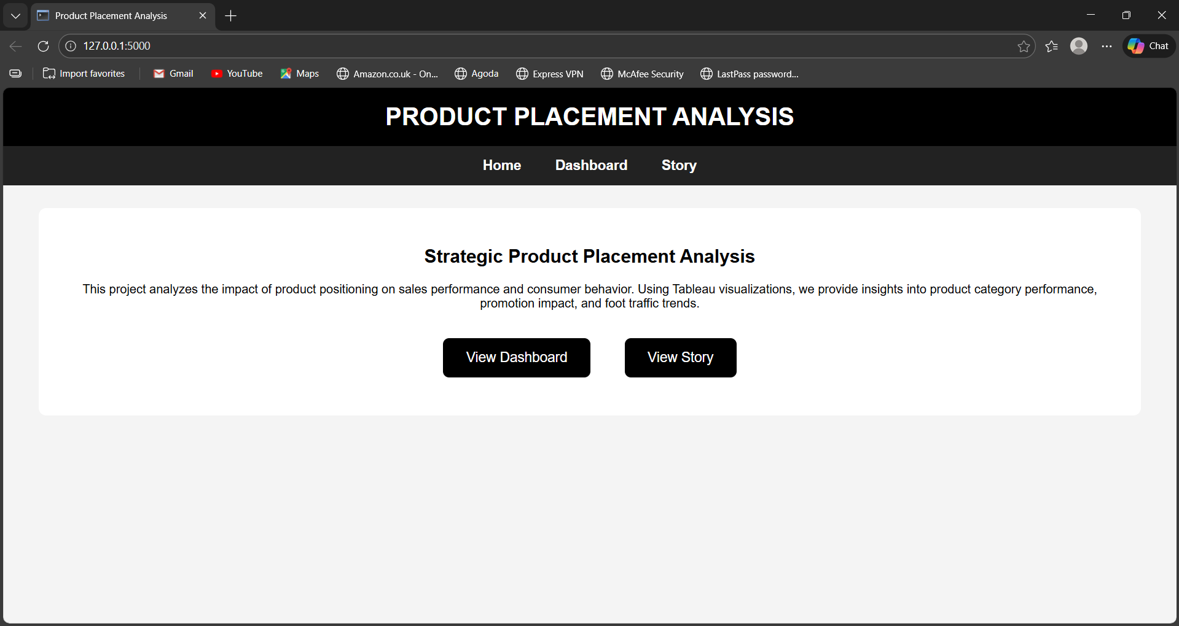
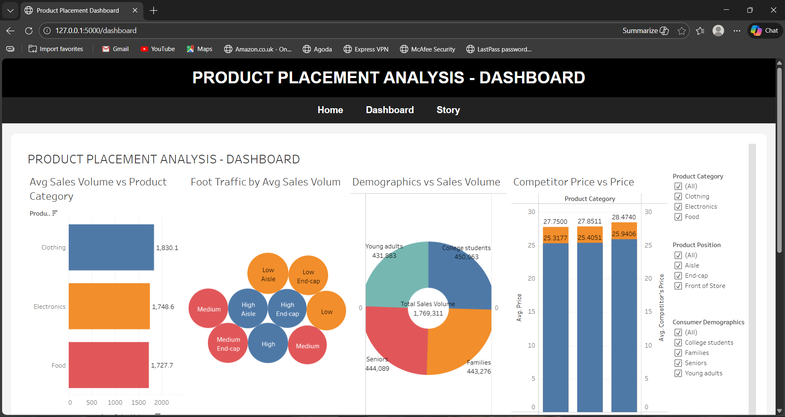
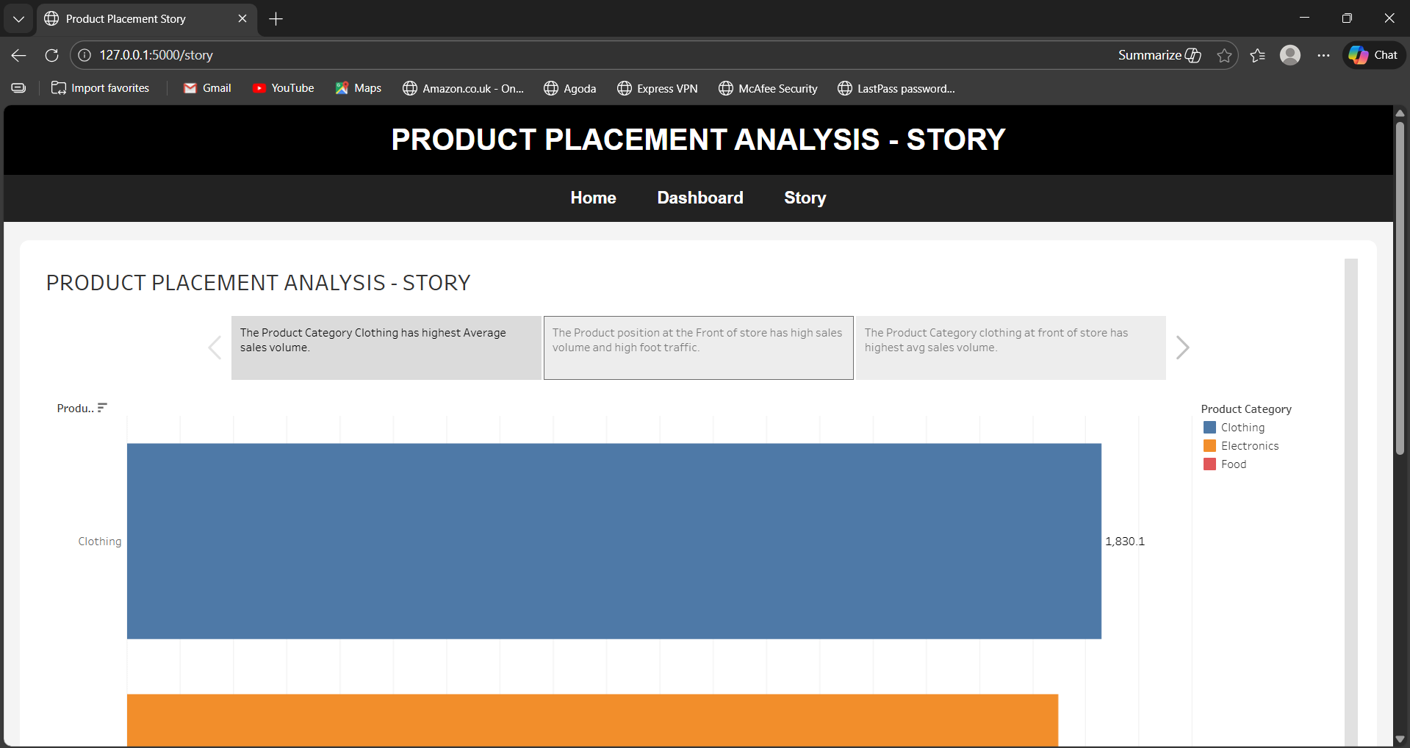
14. Conclusion
This project successfully analyzed supermarket product placement strategies using Tableau visualizations. The dashboard and story provide clear insights into how product category, product position, promotions, foot traffic, and demographics affect sales volume.
The analysis shows that strategic placement of products in high visibility areas such as front-of-store and end-cap positions can significantly increase sales. Retail businesses can use this solution to optimize their store layout and improve overall profitability.

